**GCD RECURSIVE**

#include<stdio.h>

int gcd(int n1,int n2)

{

int rem;

if (n2 == 0)

return n1;

else

return gcd(n2,n1%n2);

}

int main()

{

int num1,num2 , GCD;

printf("Enter two numbers:");

scanf("%d%d",&num1,&num2);

GCD = gcd(num1,num2);

printf("GCD of %d and %d is %d",num1,num2,GCD);

}

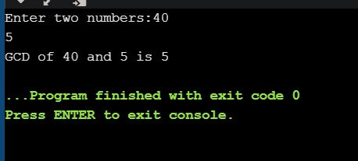

**GCD ITERATIVE**

#include<stdio.h>

int main()

{

int num1 , num2 , rem;

printf("Enter two numbers:");

scanf("%d%d",&num1,&num2);

if(num1<num2)

{

num1 = num1+num2;

num2 = num1-num2;

num1 = num1-num2;

}

while(num2 != 0)

{

rem = num1 %num2;

num1 = num2;

num2 = rem;

}

printf("GCD is %d",num1);

}

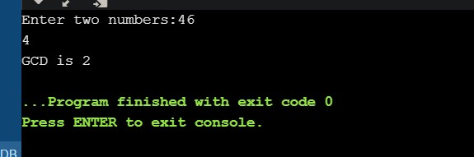

**BINARY SEARCH**

#include<stdio.h>

int binarysearch(int arr[],int key,int n1,int n2)

{

int mid = n2/2;

if (arr[mid] == key)

printf("Key id found in position of %d",mid);

if (arr[mid]<key)

return binarysearch(arr,key,n1 ,mid);

if (arr[mid]>key)

return binarysearch(arr,key,mid,n2);

}

void swap(int *xp, int *yp)

{

int temp = *xp;

*xp = *yp;

*yp = temp;

}

void selectionSort(int arr[], int n)

{

int i, j, min_idx;

for (i = 0; i < n-1; i++)

{

min_idx = i;

for (j = i+1; j < n; j++)

if (arr[j] < arr[min_idx])

min_idx = j;

swap(&arr[min_idx], &arr[i]);

}

}

int main()

{ int i,n,key;

printf("enter the size of array: \n");

scanf("%d",&n);

int arr[n] ;

printf("Enter the elements to the array: \n");

for(i=0;i<n;i++)

scanf("%d",&arr[i]);

selectionSort(arr,n);

printf("Enter the key element to search");

scanf("%d",&key);

binarysearch(arr,key,0 ,n);

}

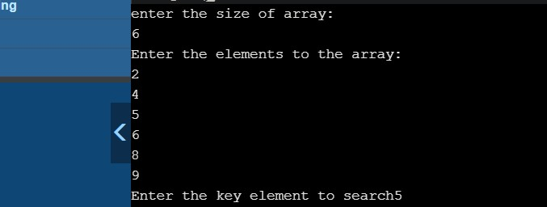

**LINEAR SEARCH**

#include<stdio.h>

int main()

{

int arr[10],i,n,key,flag=0;

printf("Enter the number of elements in array:");

scanf("%d",&n);

printf("Enter the elemnts to array:\n");

for(i=0;i<n;i++)

{

scanf("%d",&arr[i])

;}

printf("Enter the elemnts need to be found:\n");

scanf("%d",&key);\

for(i=0;i<n;i++)

{

if(arr[i]==key){

printf("Key found in position %d/n",i);

flag=1;

}

}

if(flag==0)

printf("key not found in list");

}

